LAB – 6 BROWSER FORENSICS

In this activity you will examine the cache maintained by Google Chrome using
NirSoft's ChromeCacheView and ChromeHistoryView.
Tools:
Product: ChromeCacheView
Manufacturer: NirSoft
Web site: http://www.nirsoft.net/web browser tools.html
Product: ChromeHistoryView
Manufacturer: NirSoft
Web site: http://www.nirsoft.net/web browser tools.html
Instructions:
- Download ChromeCacheView. Extract the executable from the compressed file and place it on the desktop.
- Download ChromeHistoryView. Extract the executable from the compressed file and place it on the desktop.
- Download the file named "Compressed Caches.zip" given and extract the folders to your desktop. (Keep the folder structures intact.)
- The cache for Google Chrome was extracted from the following location:
C:\Users\admin\AppData\Local\Google\Chrome\User Data\default\Cache\
- Launch ChromeCacheView.
- By default, when ChromeCacheView is launched, it will point to the cache stored on the local hard drive for the user account, which launched the application.
- From the main menu select "File" and then choose "Select Cache Folder.' Browse to the following location in Desktop:
\Desktop\Compressed_Caches\Google\Chrome\User Data\default\Cache, and click the "OK" button.
- Click on the column labeled "URL" to sort the data alphabetically by URL.
- When was www.starwars.com visited?
- When was the graphic "apple-touch-icon.png" last updated on the Star
Wars web site?
- When was www.cnn.com visited?
- Launch ChromeHistoryView. By default, the application will point to the history stored on the local hard drive for the user account, which launched the application.
- On main menu select "Options" and then select "Advanced Options."
- Check the box next to "Use the following history file."
- Browse to the following location in the Desktop:
Desktop\Compressed Caches\Google\Chrome\UserData\Default\History, and click the "OK" button.
- How many sites were visited?
Activity 2: Analyzing Firefox Internet Cache and History
In this activity you will examine the cache maintained by Mozilla Firefox using
NirSoft's MozillaCacheView and MozillaHistoryView.
Tools:
Product: MozillaCacheView
Manufacturer: NirSoft
Web site:http://www.nirsoft.net/web browser tools.html
Product: MozillaHistoryView
Manufacturer: NirSoft
Web site: http://www.nirsoft.net/web browser tools.html
Instructions:
- Download MozillaCacheView. Extract the executable from the compressed file and place it on the desktop.
- Download MozillaHistoryView. Extract the executable from the compressed file and place it on the desktop.
- Download the file named "CompressedCaches.zip" given and extract the folders to your desktop. (Keep the folder structures intact.)
- The cache for Mozilla Firefox was extracted from the following locations:
C:\Users\admin\AppData\Local\Mozilla\Firefox\Profiles\profile.default\Cache C:\Users\admin AppData\Roaming\Mozilla\Firefox\Profiles\profile.default places.sqlite\
- Launch MozillaHistoryView.
- When MozillaHistoryView is launched, the user will be prompted to enter the path to the places.sqlite database. By default, the application will look inside the local user's profile. Browse to Desktop\Compressed Caches\Mozilla
.default\places.sqlite. (Note: It will be necessary to change the file type setting in the lower right corner of the screen using the pull-down menu. Change the option from "Mozilla history.dat to File (*.dat)" to "Firefox 3 places File (*.sqlite).) Click the "OK" button.
- How many sites were visited?
- Scroll to the right site of the window and review the column named "Record
Index. '
- Which site was visited last?
- Launch MozillaCacheView.
- Redirect MozillaCacheView to the following directory in the Desktop: Desktop\Compressed Caches\Mozilla\AppData\Local\Mozilla\Firefox\Profile s\9asfx3h5.default\cache2 and press the "OK" button.
- For the four visited web pages, how many items were cached?
- What is the only site to return an HTTP status code of 206, where the server returned only partial content?

Activity 3: Analyzing Browser History using DB Browser for SQLite
In this activity you will examine the browsing history maintained by Google Chrome using DB Browser for SQLite. Chrome stores browsing history in a SQLite database called History, which contains information about visited URLs, visit counts, and timestamps.

Tools
Product: DB Browser for SQLite
Manufacturer: SQLite Team
Web site: https://sqlitebrowser.org/

Instructions
- Download DB Browser for SQLite and install the application on the system.
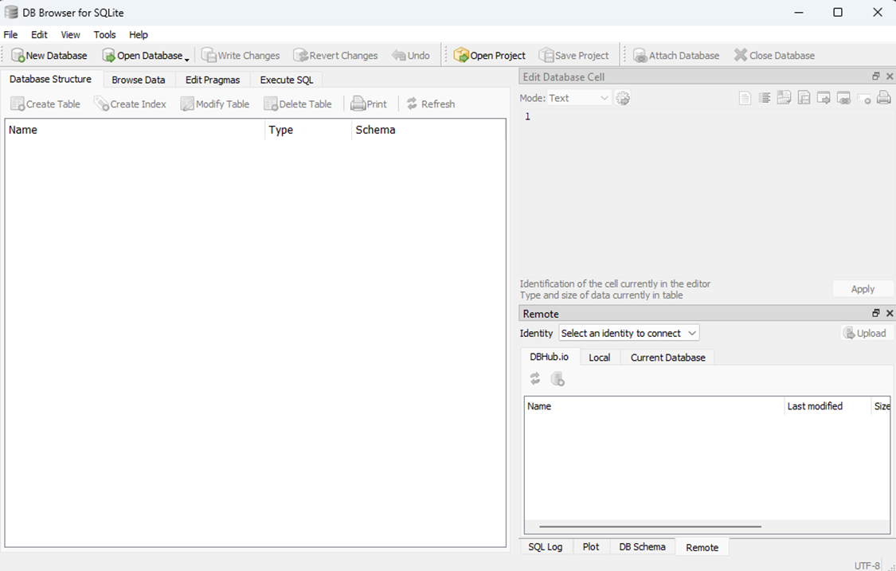
- Launch DB Browser for SQLite.

- Download the file named DB analysis.zip given and extract the folders to your desktop.
(Keep the folder structures intact.)
- The Chrome History database was extracted from the following location:
C:\Users\admin\AppData\Local\Google\Chrome\User Data\Default\History
- Click Open Database in DB Browser for SQLite.
- Browse to the following location (Make sure to select All files):
\DB analysis\History
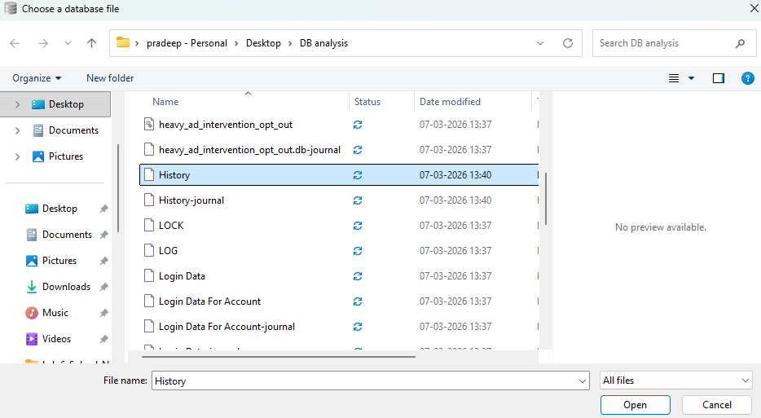
and click the Open button.
- Click on the Browse Data tab.
- From the Table drop-down menu select the table named urls.
- Review the list of visited URLs in the table.
How many URLs are present in the urls table?
- Observe the column named visit_count.
Which website was visited the most number of times?
- Review the last_visit_time column.
Which website was visited most recently?
- Now select the table named visits.
- Examine the records in the visits table.
How many browsing records are present in the visits table?
- Click on the Execute SQL tab.
- Run the following example query:
SELECT url, visit_count
FROM urls
ORDER BY visit_count DESC;

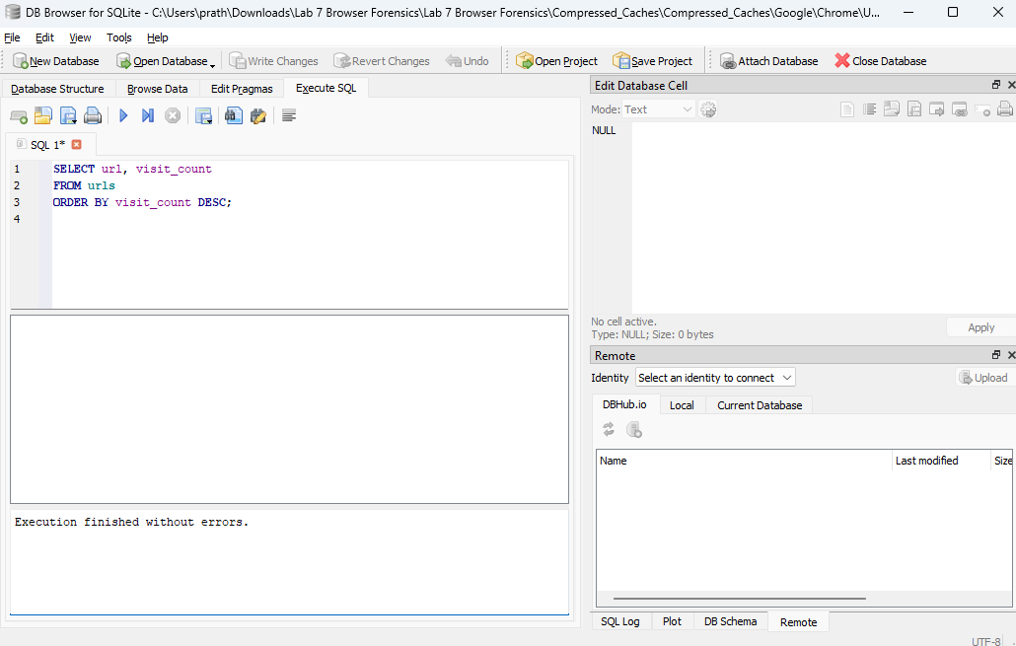
- Review the results returned by the query.
Which are the top 4 most visited websites according to the database?

